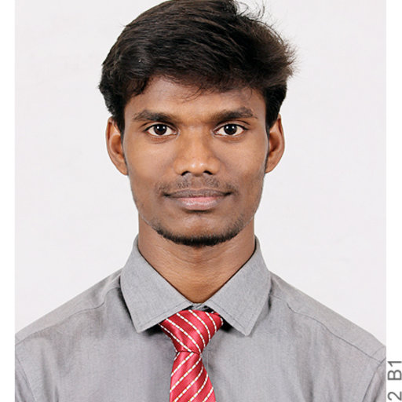

Candidate Information Form

GUIDELINES TO FILL FORM
- Use black ink to fill the form
- Please write in block letters

Personal Details

Full Name (as per govt id proof): VIGNESH ARVIN G
Date of Birth |  |  |  |  |  | 19-10-1997
Marrital Status |  |  |  |  |  | SINGLE
Spouse’s Name( If Married) |  |  |  |  |  | NA
If spouse is working, please indicate the profession |  |  |  |  |  |  |  |  | NA
If spouse is working with CGI, please mention |  |  |  |  |  |  |  | PSA ID |  |  | NA |  | Project Name |  |  |  | NA

Nationality: INDIAN
Current Location |  |  |  | DHARMAPURI |  |  |  |  | Preferred Job location |  |  |  |  |  | CHENNAI, BANGALORE
Passport Details | Yes | YES |  |  | No |  |  | Passport number |  |  |  | T4582249 |  |  |  | Valid upto |  | 05-06-2029

PAN No: AXIPV2258E

Contact Details
Contact Number (Mobile) |  |  | 9600914154 |  |  |  |  |  |  | Contact Number (Landline) |  |  |  | NA
Email ID: ARVIN.VIGNESH@GMAIL.COM |  |  |  |  |  |  |  |  |  | Alternate Email ID: NA

Alternative Mobile Number (Family): 8525989468

Alternative Mobile Number (Friends): 9500651342

Academic Details (Please write in Block letters, please do not use short forms)
Particulars | Class X | Class XII / PUC | Graduation/ Engineering | Post-Graduation
Name of the degree | NA | NA | BACHELOR OF ENGINEERING | NA
Specialization/  Stream | NA | MATHS-BIO | ELECTRICAL & ELECTRONICS ENGINEERING | NA
Name of the School/ College | D.D.C.S.M.MATRICULATION SCHOOL | SRI VIDYA MANDIR MATRIC HR SEC SCHOOL | KUMARAGURU COLLEGE OF TECHNOLOGY | NA
Name of the University/Board | STATE BOARD | STATE BOARD | ANNA UNIVERSITY | NA
Year of passing | 2013 | 2015 | 2019 | NA
Percentage/Class  /CGPA | 96.4% | 94.83% | 7.78 CGPA | NA

Candidate Information Form

Name of the candidate | VIGNESH ARVIN G

Additional Courses / Certifications (If Any)
Certificate/Course Name | Specialization | College/Institution |  |  |  | Year of Passing |  | Percentage/Class
NA | NA | NA |  |  |  | NA |  | NA

Gaps / Breaks in Education (If any)
From Date | To Date |  | Degree / Course | Duration | Remarks / Reason for Gap
NA | NA |  | NA | NA | NA
Minimum time required to join (In Days) |  |  |  |  | 60 DAYS
Have you been interviewed by CGI in last 6 months |  |  |  |  | YES |  |  |  | NO | NO

Employment History (In Chronological Order)
From Date | To Date |  |  | Duration (In Months) |  |  | Organization | Designation
17-06-2021 | STILL WORKING |  |  | 4 MONTHS |  |  | NETCRACKER TECHNOLOGY SOLUTIONS | SOFTWARE ENGINEER
28-05-2019 | 14-06-2021 |  |  | 24 MONTHS |  |  | COGNIZANT TECHNOLOGY SOLUTIONS | PROGRAMMER ANALYST

Gaps / Breaks in Career (If any)
From Date |  | To Date | Duration (In Months) |  |  | Remarks / Reason for Gap
NA |  | NA | NA |  |  | NA
Total Experience (in months) |  |  |  |  | 29 MONTHS
Relevant Experience (in Yrs) |  |  |  |  | 2.5 YEARS

I hereby declare that all information furnished here are true and correct to the best of my knowledge and belief.

Date: 28-10-2021 Signature: VIGNESH ARVIN G

